# eRIC Nitro board testing

Suggested test sequence,

* Test the eRIC module in standalone mode
* Test the Arduino in standalone mode
* Test the Arduino communication with the eRIC using Arduino software UART
* Test the Arduino communication with the eRIC using Arduino hardware UART

# Test setup – eRIC module in standalone mode

To test eRIC module in standalone mode on Nitro board (verifying part of the eRIC PCB design and PCB assembly), requires,

* 1 x assembled Nitro board, fully populated including all components including SIL headers strip and wire antenna (see later)
* 1 x FTDI – USB-serial 3.3V cable
* 1 x female-female jumper cable
* 1 x Windows PC
* 1 x easyRadio software (see later)

# Test Procedure – step 1

1. At this point it is assumed that the Nitro board has been checked to confirm (at least) to no shorts between Vin and GND (0V) and 3.3V and GND(0V).
2. The LPRS website page <http://www.lprs.co.uk/resource-centre/downloads/eric-software-datasheets/eros-4-files.html> contains the documentation and software for the eRIC module

Download the easyRadio software at <http://www.lprs.co.uk/assets/media/easyRadiosetup%204.0.5.exe>

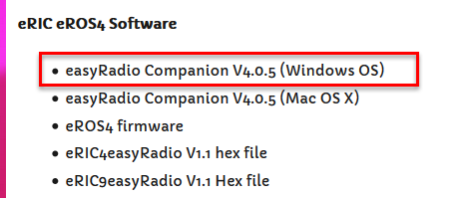

And install it.

1. Get your FTDI cable ready. Don’t connect it to the Nitro or PC just yet.
2. Get the Nitro board ready as follows,

* Populate the Nitro board FTDI header (1) with a male 6 pin header so that it can mate with the female end of a FTDI connector.

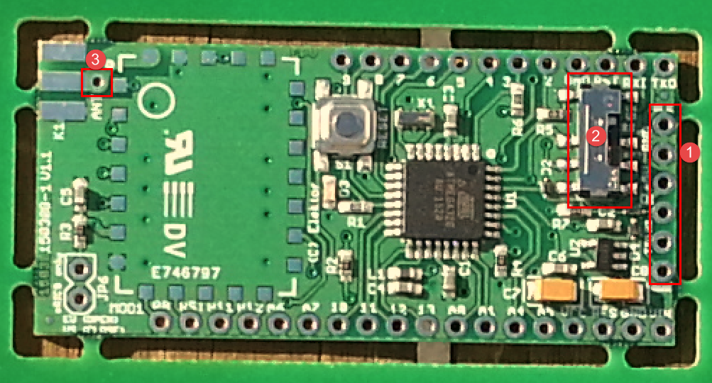

* There are 2 options for a board level antenna. Either connect an SMA antenna or solder a simple ( ¼ wavelength) wire antenna to the board (3) . The antenna length for an eRIC 9 module is 86mm. For a eRIC 4 module it is 173mm.
* Put Nitro board switch (2) into middle position so that the RX/TX pins of the eRIC are directly connected to the FTDI header RX/TX pins
* Using a wire jumper, connect Arduino RST pin to 0V, as this will force all ATMega328 pins into high impedance state when power is applied to the board.
* Connect the FTDI cable to the Nitro FTDI header. Pay special attention to make sure the polarity is correct – the FTDI GND pin must mate with the Nitro FTDI header Lx GND (or 0V) pin. Once this is done, connect USB end of FTDI cable to computer USB port. This will power up the Nitro board including the eRIC

1. Start the easyRadio software

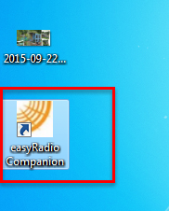

1. This will open a dialog box, but you can select “Not Now” to skip this section

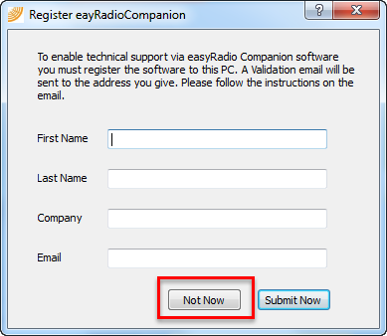

1. Select eRIC radio button (1) and then “OK” button (2) to select the eRIC module

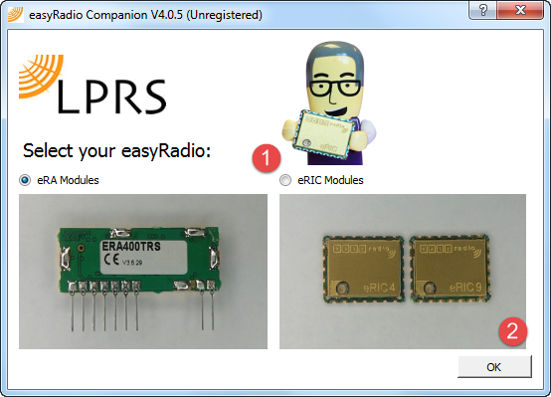

1. Next setup the FTDI serial connection settings from within the easyRadio software.

* Select the appropriate port from drop down list (1)
* Leave the baud rate(2) at whatever value it is set at, since the easyRadio software will try and autodetect the eRIC baud rate, and the value (2) may change.
* Set handshaking as none (3)
* Click on the “Open port” button to open the FTDI virtual COM port (4).

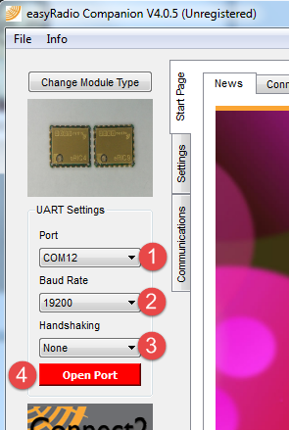

1. Click on the settings (1) and the then the module info (2) tabs.

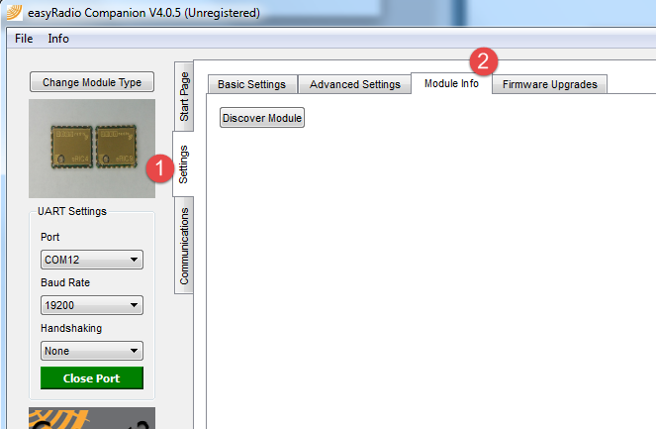

1. Click on “Discover Module” (1). The easyRadio software will try and autobaud connect to the eRIC module on the specified port.

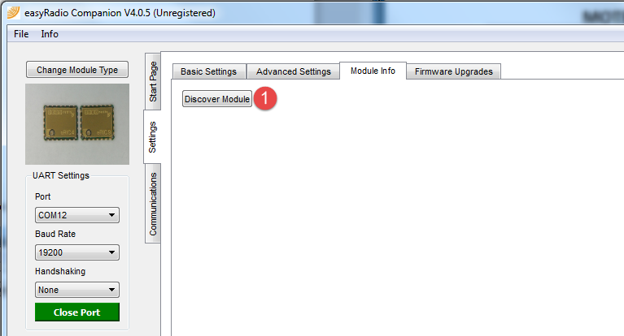

If all is okay (i.e. eRIC not dead, no problems with FTDI<-> eRIC RX/TX connections or power to eRIC etc.), then you should see a screen similar to the one below, where all of the information related to App Code, OS, BSL etc. has been read from the eRIC module over the RX/TX interface.

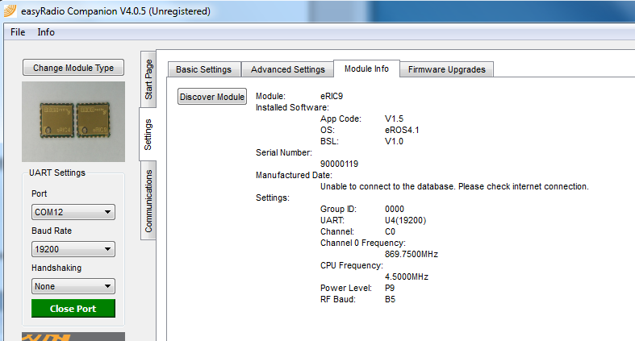

This is a good sign that the basic eRIC-FTDI electrical connections are good, but to verify the PCB design and assembly further needs a second module and another set of test steps. See next section.

# Test Procedure – step 2

Step 2 requires another Nitro board to be assembled and tested as per step 1. This will require a second FTDI cable and a second female-female jumper.

Confirm the 2nd Nitro board hardware by repeating actions 1, 3-10 from step 1 above. No action 2 is necessary if the easyRadio software has already been downloaded and installed. Both Nitro boards must be of same type i.e. both eRIC 4, or both eRIC 9, and both must have same firmware revision.

We can now test the RF interface.

1. Close all instances of the easyRadio software.
2. Remove FTDI cables from PC.
3. Connect **first** FTDI cable to 1st Nitro board and insert FTDI cable USB to PC.
4. Connect **second** FTDI cable to 2nd Nitro board and insert FTDI cable USB to PC.
5. Keep both Nitro board at least 30cm apart to avoid RF swamping i.e. avoid overloading Nitro 2 radio receiver with too large a signal from Nitro 1.
6. Open easyRadio software and repeat action 6, 7, 8 for 1st module. Then select communications tab (1)

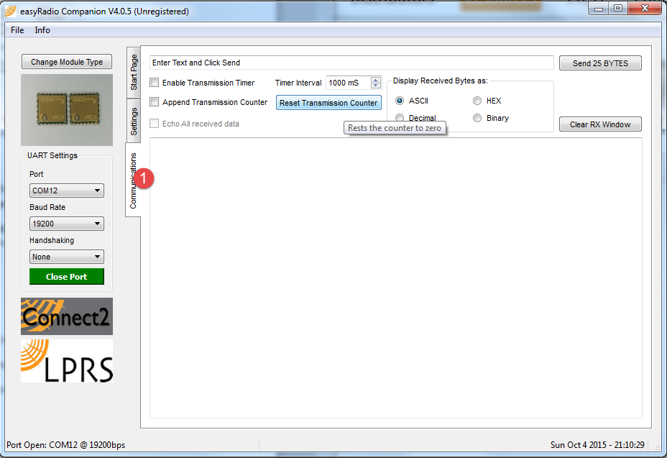

1. Open second instance of easyRadio software and repeat action 6, 7, 8 for 2nd module. Then select communications tab (1) again in second instance. On your screen you might see something like this, (In this image we have 2 Nitro boards connected to port 12 and 15 have been used on the PC.)

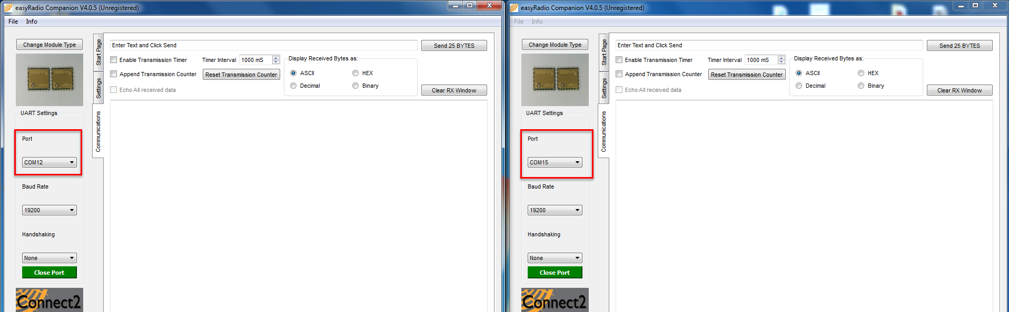

1. On 1st instance of software at (1) type in a message to be sent to 2nd Nitro board, then click on Send button (2). If all is okay and Nitro 2 is receiving , then the message from Nitro 1 should appear on Nitro 2 at (3)

